E.E.AT. D-100 “DIVINA PROVIDENCIA”
4TO AÑO CICLO SUPERIOR
ESPACIO CURRICULAR: LENGUA EXTRANJERA INGLÉS
TRABAJO PRÁCTICO EXTRA ÁULICO N° 2
PROFESORA: JÉSICA FOGEL
MARZO 2020

INSTRUCCIONES GENERALES
- Leer detenidamente las consignas y tomar en cuenta el ejemplo brindado en cada actividad antes de resolverlas.
- Retomar conocimientos previos, carpeta y/o libro del año anterior.
- Utilizar diccionario bilingüe confiable, impreso u online (https://www.lexico.com/es).
- Una vez resueltas, imprimir las actividades o transcribirlas en forma prolija y con letra legible para ser agregadas a la carpeta.
- Entregar antes de las 10 p.m. del día martes 7 de marzo.
ACTIVITIES
- Read and analyse the differences between these two verb tenses: Present Simple and Present Continuous.
We use Present Simple for:  - habitual actions  (+) I always get up early on Mondays.  (-) We don’t go to school on Sundays.  (?) What do you usually do at weekends?  - a permanent situation  (+) Lucy lives in London.  (-) My best friend doesn’t play football anymore.  (?) What subjects do you study at school?  - facts, general truths  (+) Water boils at 100⁰Celsius.  (-) It doesn’t rain very much in summer.  (?) Does water freeze at 0 degrees?  (*See VERB FORMS on page 4) | We use Present Continuous for:  - something that is happening at the moment of speaking  (+) It is raining outside.  (-) The boys aren’t sleeping now.  (?) What are you doing in the kitchen, mom?  - a temporary situation  (+) I am staying at a friend’s house tonight.  (-) You are working very hard today.  (?) What are you studying?  - an action in the near future  (+)I am staying at a friend’s house tonight.  (-) My mom isn’t cooking pizzas tomorrow.  (?) Where are you travelling next week?”  (*See VERB FORMS on page 4)

- Time expressions help us identify the verb tenses in sentences. Put these time expressions in the correct column. Translate them into Spanish.

always – now – sometimes – often – in this moment – never – this Saturday – usually – at the weekends – every day – right now – once a month – Silence! – three times a week – at the moment – Listen! –
on Mondays – Shhh! – tomorrow – in the morning – this evening – today – Look! – this summer –
hardly ever - at present – twice a year – rarely – next week – occasionally
Present Simple | Present Continuous
Always (siempre) | Now (ahora)
- Complete each pair of sentences with the correct form of the verb in Present Simple or Present Continuous. Underline the time expressions.
For example:
*COOK
- My mother _is cooking_ a pizza in this moment. (Present Continuous)
- I usually _cook_ pizzas on Saturday evenings. (Present Simple)
*SLEEP
- I ____________________for a long time at the weekends.
- Shhh! The baby ____________________ upstairs.

*PLAY
- Listen! The boys ____________________ the guitar.
- I ____________________ online games every day.

*READ
- Right now my mum ____________________ a magazine.
- My dad usually ____________________ the newspaper in the morning.

*WATCH
- Now we ____________________ our favourite series on Netflix.
- On Sundays we ____________________ TV in the evening.

- Look at the pictures and write sentences comparing Peter, Mary and little John’s routines with what they are doing today.

On a typical day | Today
For example:
On a typical day, Peter wakes up at 7:00 a.m. (Present Simple)
Today he’s waking up at 9:00 a.m. (Present Continuous)
______________________________________________

______________________________________________

______________________________________________

______________________________________________

______________________________________________

______________________________________________

______________________________________________

______________________________________________

- Complete these affirmative sentences with the Present Simple or Present Continuous form of the verbs. Then, rewrite them in the negative (-) and interrogative (?) forms.
For example:
- We _play_ (play) computer games every day. (Present Simple)
(-) We don’t play computer games every day.
(?) Do we play computer games every day?

- Jane _is eating_ a sandwich right now. (Present Continuous)
(-) Jane isn’t’ eating a sandwich right now.
(?) Is Jane eating a sandwich right now?

- You _________ (take) an exam today.
(-)
(?)

- They always _________ (watch) TV in the afternoon.
(-)
(?)

- Lucas _________ (do) the homework now.
(-)
(?)

- I _________ (study) English three times a week.
(-)
(?)

- Read the text below and answer the questions below.

My friend Alison is a technology freak. She can’t do anything if she is not connected. She is a gossip, so she loves Facebook because she can see everybody’s photograph there. She can immediately what her friends are doing or whom they are dating.
As soon as she reads something on the net, she sends emails or texts her friends with her new mobile. And she can stay long hours chatting online with friends. And now she’s delighted with Twitter. She’s connected with the world in seconds!
If she goes jogging, she takes her MP4 with her because she listens to music. When she goes cycling, she takes her father’s GPS to find her way back home. And she usually takes her camera to photograph anything she likes on her way.
She can’t solve any Maths problem if she doesn’t have her calculator. And she always surfs the net to do her homework. Nowadays, she’s doing a lot of English homework. But there is only one thing she can’t change. She loves reading real books because she can read them comfortably in bed. She’s reading the Twilight novels at the moment.

- Does Alison love technology?
- Which social networking sites does she use?
- Does she have a new mobile phone?
- What does she do while she goes jogging?
- How often does she take her camera while cycling?
- Is she doing a lot of Maths homework?
- Does she read online books?
- What is she reading at the moment?
*VERB FORMS
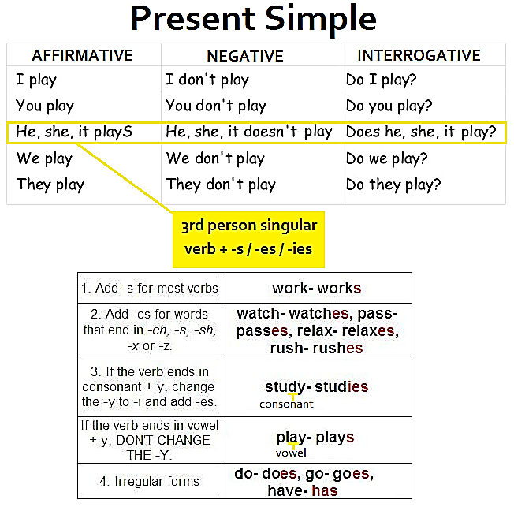

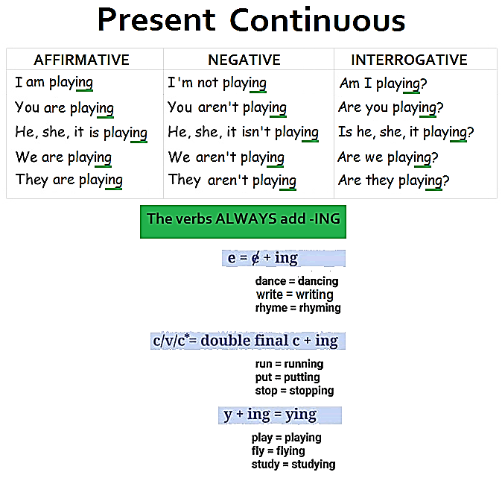

No puede
Puede

