E.E.AT. D-100 “DIVINA PROVIDENCIA”
5TO AÑO CICLO SUPERIOR
ESPACIO CURRICULAR: LENGUA EXTRANJERA INGLÉS
TRABAJO PRÁCTICO EXTRA ÁULICO N° 5
PROFESORA: JÉSICA FOGEL
FECHA LÍMITE DE ENTREGA: Lunes 1/06/20

INFORMACIÓN IMPORTANTE
Leer detenidamente las consignas. Consultar cualquier tipo de dudas durante el horario de cursado (8 a 16 horas) y en días hábiles. No dejar las actividades incompletas por no leer o comprender las consignas correctamente.
Tomar en cuenta el ejemplo brindado en cada actividad antes de resolverlas.
Es imprescindible utilizar un diccionario bilingüe confiable, impreso u online (link: https://www.lexico.com/es) durante la realización de las actividades.
Realizar los trabajos en forma individual, según su comprensión y conocimientos. Aquellos trabajos que sean copiados entre alumnos serán ANULADOS.
Imprimir las actividades o transcribirlas en forma prolija y con letra legible (utilizando birome) para ser agregadas a la carpeta.
Entregar los trabajos en tiempo y forma, colocando nombre y apellido del estudiante, curso, asignatura, escuela, etc. en la parte superior.

ACTIVITIES

- Look at the complete chart of GRADED ASSIGNMENT N° 4 and correct your own answers if necessary.
SPANISH TRANSLATION | ADJECTIVE | COMPARATIVE FORM | SUPERLATIVE FORM
Viejo  Moderno  Feo  Aburrido  Limpio  Hermoso  Bien – Bueno  Grande  Incomodo  Pesado  Mal – Malo  Interesante  Liviano  Elegante  Grande  Corto – Bajo  Rápido  Largo  Ruidoso  Barato  Importante  Caliente  Lejos  Ancho | - Old  - Modern  - Ugly  - Boring  - Clean  - Beautiful  - Good  - Large  - Uncomfortable  - Heavy  - Bad  - Interesting  - Light  - Elegant  - Big  - Short  - Fast  - Long  - Noisy  - Cheap  - Important  - Hot  - Far  - Wide | Older than  More modern than  Uglier than  More boring than  Cleaner than  More beautiful than  Better than  Larger than  More uncomfortable than  Heavier than  Worse than  More interesting than  Lighter than  More elegant than  Bigger than  Shorter than  Faster than  Longer than  Noisier than  Cheaper than  More important than  Hotter than  Father/further than  Wider than | The oldest  The most modern  The ugliest  The most boring  The cleanest  The most beautiful  The best  The largest  The most uncomfortable  The heaviest  The worst  The most interesting  The lightest  The most elegant  The biggest  The shortest  The fastest  The longest  The noisiest  The cheapest  The most important  The hottest  The farthest / the furthest  The widest
Irregular Adjectives
- Complete these sentences with the comparative or superlative form of the adjectives in the previous chart.

For example:
COMPARATIVE | SUPERLATIVE
The Paraná river is wider than the Uruguay river.  (El río Paraná es más ancho que el río Uruguay.) | The Parana river is the widest in Argentina.  (El río Paraná es el más ancho en Argentina.)
- The Peregrine Falcon is ____________ the ostrich. | The Peregrine Falcon is ____________ bird.
- Church of the Nativity (1,685 years) is ____________ St. Peter’s Basilica (512 years). | Church of the Nativity is one of ____________ sacred places in the world.
- Death Valley (USA) is ____________ Hermosillo (Mexico). | Death Valley (USA) is ____________ place in the planet.
- Russia is ____________ China. | Russia is ____________ country in the world.
- The IPhone 11 is ____________ the Samsung J7 mobile phone. | The IPhone 11 is ____________ mobile phone.

- Add three examples of your own.

COMPARATIVE | SUPERLATIVE

- Look at the three rooms below.

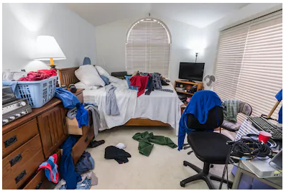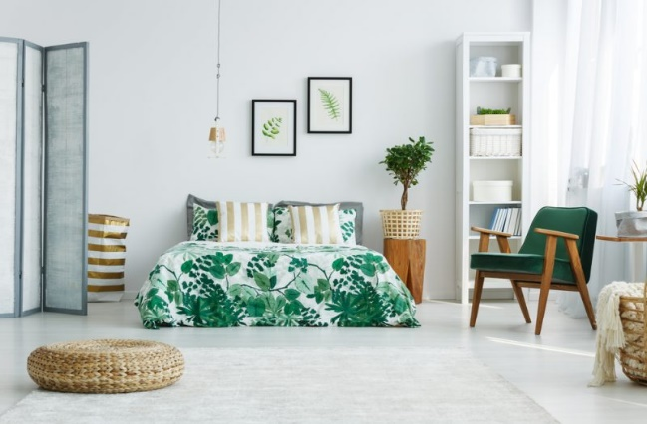
ROOM 2
ROOM 1
ROOM 3
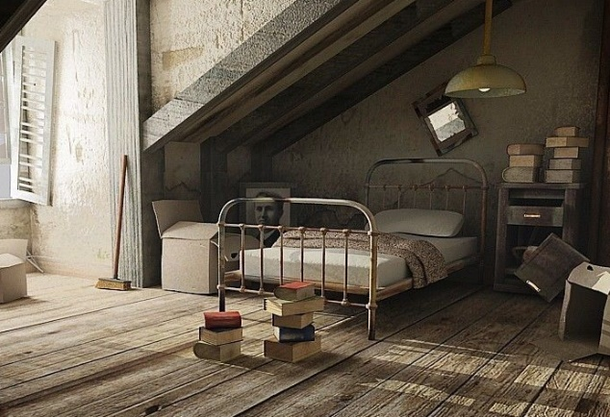
- Write 10 sentences comparing the three rooms. Use the comparative and superlative forms of these adjectives.

messy – tidy – old – modern – dark – comfortable – dirty – big – small – uncomfortable

For example:

COMPARATIVE
Room 1 is messier than room 2.
- ____________________________________
- ____________________________________
- ____________________________________
- ____________________________________
- ____________________________________

SUPERLATIVE
Room 1 is the messiest.
- ____________________________________
- ____________________________________
- ____________________________________
- ____________________________________
- ____________________________________

