E.E.AT. D-100 “DIVINA PROVIDENCIA”
4TO AÑO CICLO SUPERIOR
ESPACIO CURRICULAR: LENGUA EXTRANJERA INGLÉS
TRABAJO PRÁCTICO EXTRA ÁULICO N° 5
PROFESORA: JÉSICA FOGEL
FECHA LÍMITE DE ENTREGA: Lunes 1/06/20

INFORMACIÓN IMPORTANTE
Leer detenidamente las consignas. Consultar cualquier tipo de dudas durante el horario de cursado (8 a 16 horas) y en días hábiles. No dejar las actividades incompletas por no leer o comprender las consignas correctamente.
Tomar en cuenta el ejemplo brindado en cada actividad antes de resolverlas.
Es imprescindible utilizar un diccionario bilingüe confiable, impreso u online (link: https://www.lexico.com/es) durante la realización de las actividades.
Realizar los trabajos en forma individual, según su comprensión y conocimientos. Aquellos trabajos que sean copiados entre alumnos serán ANULADOS.
Imprimir las actividades o transcribirlas en forma prolija y con letra legible (utilizando birome) para ser agregadas a la carpeta.
Entregar los trabajos en tiempo y forma, colocando nombre y apellido del estudiante, curso, asignatura, escuela, etc. en la parte superior.

ACTIVITIES

- Revise this explanation of the PAST of the verb to be and the TIME EXPRESSIONS for the past simple tense.
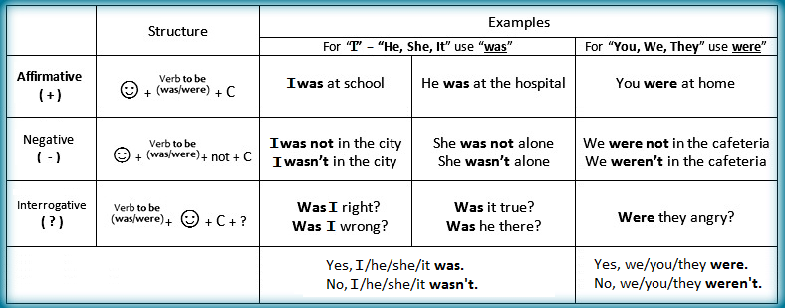
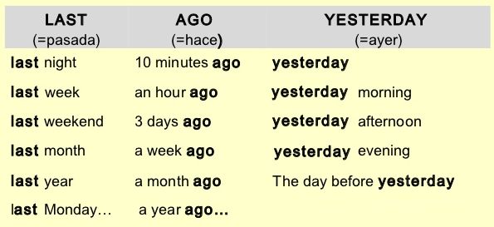
- Complete this table with the correct past form of the verb to be (affirmative, negative and interrogative).
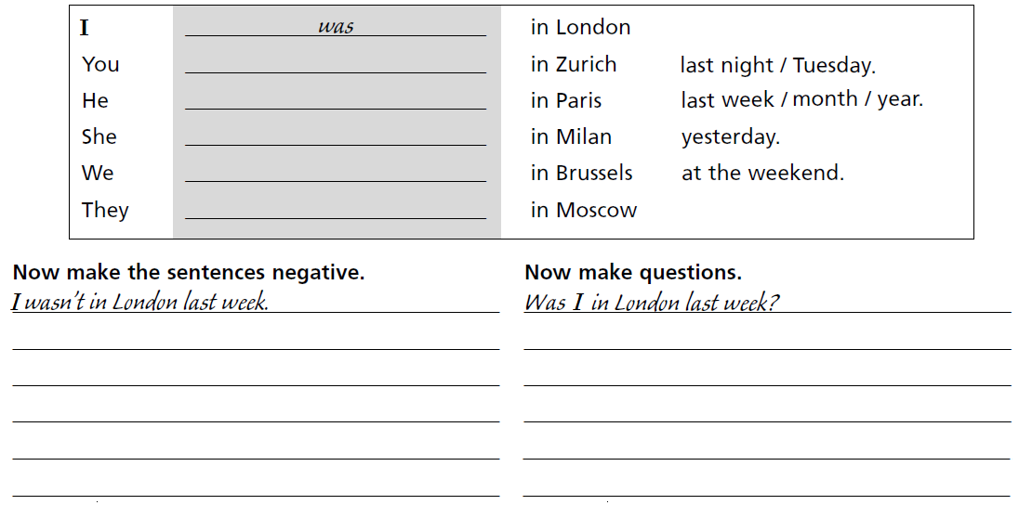
- Complete this conversation using was, were, wasn’t and weren’t. Translate the conversation into Spanish.

ROSIE: Hi Carl! Where (0) were you last night?
CARL: I (1) _________________ with Sara. We (2) _________________ at Jason’s birthday party.
ROSIE: (3) _________________ it fun?
CARL: Yes, it (4) _________________. The party (5) _________________ fantastic!
SARA: What about you, Rosie? Where (6) _________________ you?
ROSIE: I (7) _________________ with Barbara at home.
CARL: (8) _________________ Dominic with you?
ROSIE: No, he (9) _________________. I think he (10) _________________ with Kieran at the club.
SARA: But I thought they (11) _________________ with you.
ROSIE: No, they (12) _________________. They wanted to watch the football match so they left.

- Read and analyse these question words.

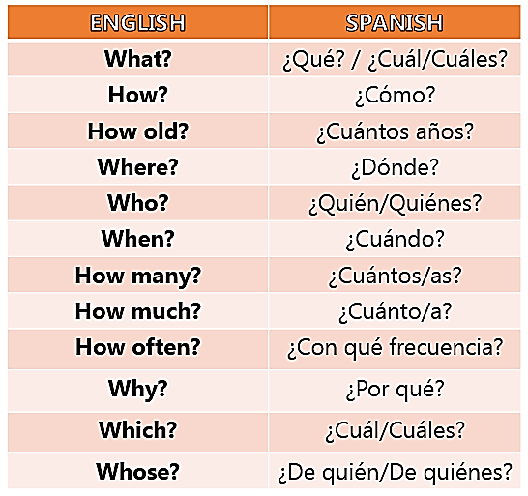
- Answer these questions with true information. Remember to give long answers.

For example: Where were you last night? I was at home.

- When were you born? I was born on…
- Which was the best present that you received when you were a child?
- Who was your favourite teacher in primary school?
- What was your favourite TV programme when you were a child?
- How many people were there in Federal in 2010? There were …
- How much was a kilogram of “asado” in Argentina in 2015?
- How old was your best friend in 2018?
- How often were you ill last year?
- How were your summer holidays?
- Where was your family last night?
- Why were you at home yesterday?

¿Cuándo naciste? Yo nací el… (completar con el día, mes y año)

